## Setup QuickSight Pipeline

This document helps understand how does the QuickSight generate graphs from the telemetry data and what is the flow.

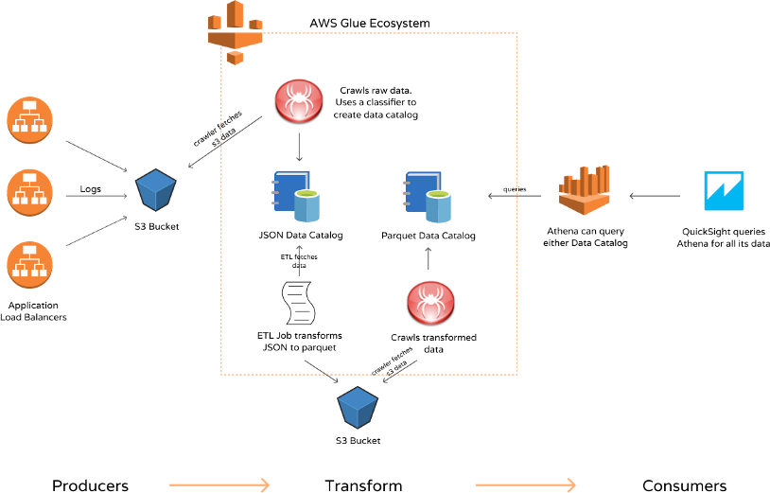

* Setup an S3 Bucket
  + This bucket is used to store the telemetry data that is sent from the gateway for further processing.
* Setup an AWS Kinesis Firehose Stream
  + This is used to hold the data coming in from the end devices.
  + Telemetry data is sent to this stream via IoT Rules
  + The fireshose stream's destination is the S3 bucket created earlier, so that this data can be used later on.
  + This does not do any data transformation
* AWS Glue
  + The data that is stored on the S3 buckets is transformed tables
  + The Glue data crawlers use inbuilt and/or custom classifies to try and to parse data.
  + The crawler will traverse your specified S3 files and group things by classifier into metadata tables in AWS Glue.
  + These tables are later used by AWS Athena for querying.
* AWS Athena
  + This queries the Glue databases and sends the output to AWS QuickSight for further analysis.
* AWS QuickSight
  + Here, we need to create a new analysis and set the source of the analysis as the Glue databases. Athena is used to query the database.
  + We can customize the charts here based on our requirements.
  + Once we have all the settings done, we need the charts to be "Published" so that they are available to everyone.
* For the ease for use, we have a cloudformation template KinesisFirehoseGlueAthena.yaml that will create all the resources mentioned above. We then need to setup the analysis manually from the AWS QuickSight dashboard.